Lab - Using Cisco Webex Teams for Developers to Messages and Rooms (Instructor Version)

In Part 1 of this lab, students will use the Creating a Room service endpoint to make an API call that will create a new Webex Teams room. Students will then use the Create a Membership service endpoint and the previously generated roomId to add another student to the room. In this lab, students will need to work in teams of at least two people. This room can also be used as the shared room in the next lab. In Part 2 of this lab, students will work in small groups to create a group and add members. (Or the instructor can create a room and add everyone in the class to the group.) Students will post messages to the shared room, along with one message not meant for this room. (These can be humorous but not inappropriate messages.) Soon after, the student will delete the incorrect message.

1. Objectives

Part 1: Creating a Room with Cisco Webex Teams for Developers

Part 2: Creating and Deleting Messages with Cisco Webex Teams for Developers

1. Background / Scenario

In this lab you will make API requests using Cisco Webex Teams for Developers to create a room, create messages, and delete messages. You use both request parameters and path parameters to accomplish these tasks.

1. Required Resources

* Cisco Webex Teams account
* Cisco Webex Teams desktop application

1. Creating a Room with Cisco Webex Teams for Developers
   * 1. Create a room.
        1. Go to the **WEBEX TEAMS API** in the Docs page of the Cisco Webex Teams for Developers web site at <https://developer.webex.com/>.
        2. Click **Docs > Rooms > Create a Room**.
        3. Besides the access token, which is entered automatically, the **Create a Room** service endpoint requires a title. Enter a name for the room in the **title** field.
        4. Click **Run**.

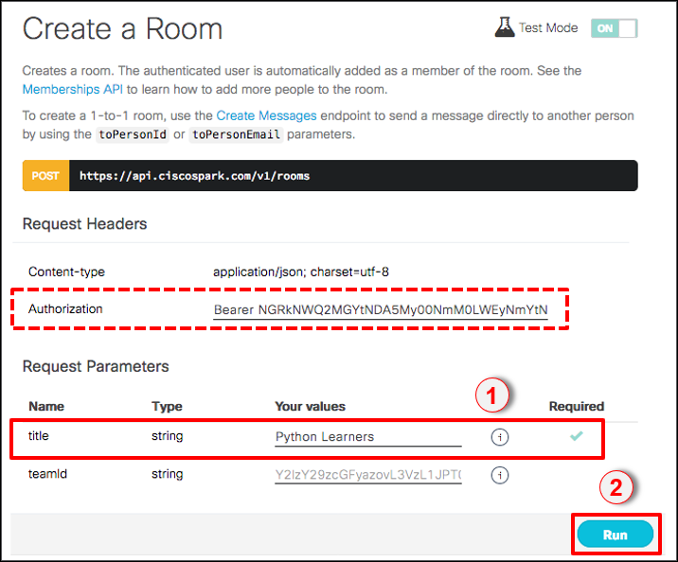

* + 1. Verify the room was created.
       1. View the JSON output and your Webex Teams application to verify the new room was created.

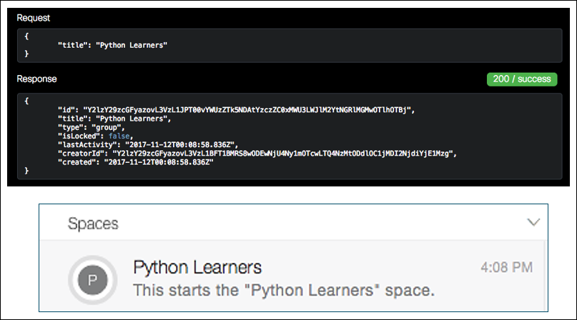

* + - 1. Copy the **id** value, without quotes. This value uniquely identifies the room. It will be used in the next two steps to get room details and add persons to the room.
    1. Get room details.
       1. Under **API REFERENCE**, click **Rooms > Create a Room**.
       2. At the end of the GET URL you will see **roomId**, in blue, followed by a down arrow. Click **roomId** and paste the ID information for the room you created in the previous step.

This is known as a path parameter. A path parameter embeds the unique identifier of a specific resource directly in the API URL. This usually implies that the parameter is for a specific resource that exists as a unique entity on the API endpoint.

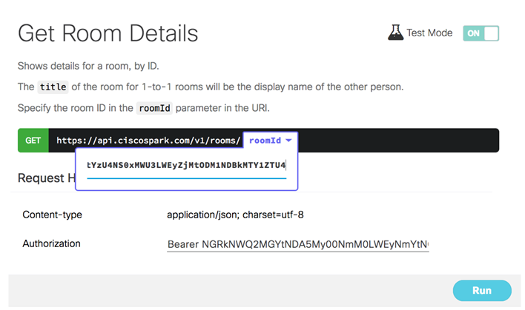

* + - 1. Click **Run** and examine the JSON information in the **Response** section. Besides the roomId, other information in the JSON response includes ID of the person who created the room and the date/time of the last activity for the room.

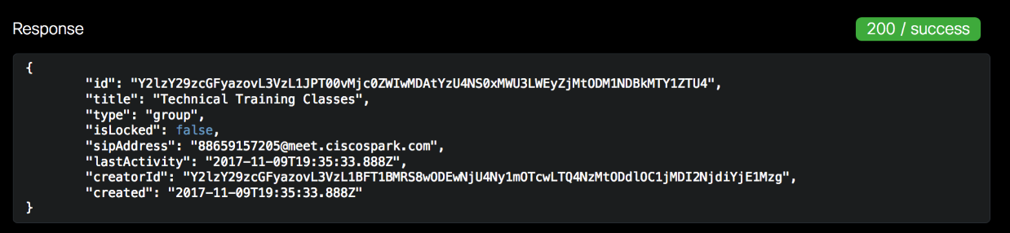

* + 1. Add a person to the room.
       1. Under **API REFERENCE**, click **Memberships > Create a Membership**.
       2. For **roomId**, paste the ID information you copied earlier in Step 2b. (You will need the **roomID** again for the next step.)
       3. For **personEmail**, add the email of someone in your class or use one of the demonstration email addresses. This must be the email address they used to create their Webex Teams account. Click **Run**.

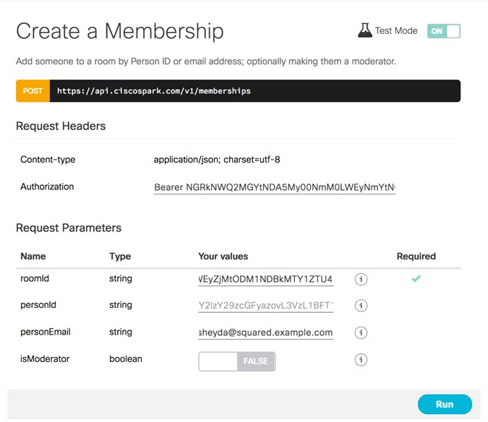

* + - 1. Verify the person was added to the group by examining the JSON output and by viewing your Webex Teams application.

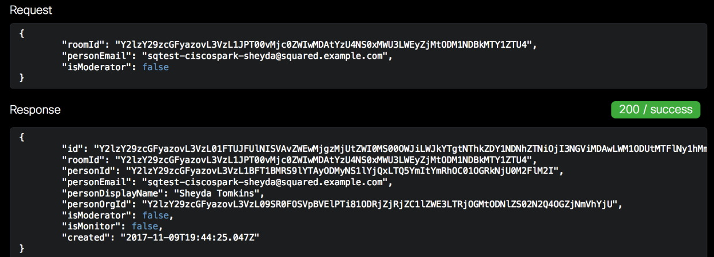

* + 1. List memberships of the room.

You can list information for all members of a room by referring to the **roomId** value.

* + - 1. Under **API REFERENCE**, click **Memberships > List Memberships**.
      2. For the **roomId** query parameter, paste the ID information you copied in Step 2b. Click **Run**.

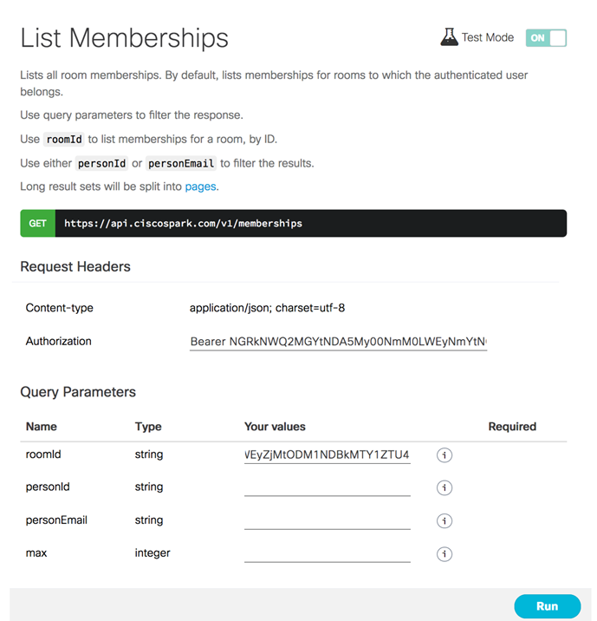

* + - 1. Examine the JSON output to verify the membership list.

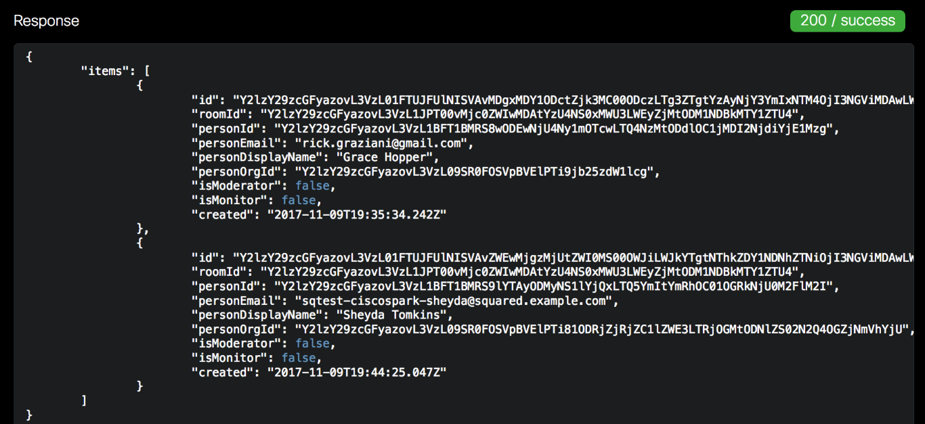

1. Creating and Deleting Messages with Cisco Webex Teams for Developers
   * 1. Join a shared group.
        1. With other members in the class, form a small group.
        2. Choose an existing room or create a new room and add everyone in the group to the room.
        3. Use the **List Rooms** service endpoint to list all the rooms and copy the **id** of this room to your clipboard. Since you will use this information several times later in the lab, it may be useful to copy it into a text document from which you can easily copy and paste.
     2. Post a message.
        1. To post messages to the room, select the **Create a Message** service endpoint under **Messages**.
        2. In the **Request Parameters** section, paste the id you copied from List Rooms into **roomId**.
        3. Enter a message that will be sent to the room members into the **text** request parameter. Click **Run**.
        4. Verify that the message was posted with a response status of **200 / success**. Look for the new message in the room using the Cisco Webex Teams application.
        5. Post several messages using the API.
     3. List messages.
        1. Go to the **List Messages** service endpoint under **Messages**.
        2. In the Query Parameters section, paste the id for the room that you copied from List Rooms into **roomId**.
        3. Click **Run** to view the messages.
        4. Choose one of the messages that you created to delete. Copy the **id** of the message. This **id** value uniquely identifies a specific message.
     4. Delete a message.
        1. Go to the **Delete a Message** service endpoint under **Messages**.
        2. At the end of the DELETE URL, click on **messageId** and paste in the i**d** value from the previous step.
        3. You will be asked to confirm this operation, press **Continue**.
        4. Verify that the message was deleted with a response message of **204 / nocontent** and by verifying that the message was deleted from the room by using the Cisco Webex Teams application.